Summary of Lecture “RF and Microwave Technology”.
The course is designed for 3rd year (undergraduate) students of electronics faculty who have successfully completed (credited with) the course and classes “Wave Electrodynamics” during the 2nd year of studies.

Specificity of RF and Microwave Techniques. Elements of Transmission Line Theory. Impedance Transformation through Transmission Line Segment. Smith Chart Origin and Examples of its Applications. Impedance Matching. Scattering Matrix and Properties of its Coefficients. Signal Flow Graphs and Mason’s Rule. Graph Analysis of an Amplifying Circuit. Amplifier Transducer Gain. Unilateral Amplifier. Gain Control and Constant Gain Circles. Design Example. Two-port Stability, Circles and Stability Conditions. Bilateral Amplifier. Two-side Matching. Gain Definitions and their Applications. Computation of Noise; Four Noise Parameters and Constant Noise Circles. Example of Low Noise Amplifier Design. Modern Microwave Transistors (BJT, HBT, MESFET, HEMT). Passive Lumped Elements and their Modelling. Planar Transmission Lines (especially Microstrip) and their Discontinuities. Review of Passive Distributed Structures (resonant circuits, filters, couplers, power dividers, phase shifters). Balanced Networks. Design of Circuit Layout. DC Bias Networks. Design Example of an Amplifier Layout. Oscillator Theory and Design Example. Non-linear Properties of Low-Signal Circuits (Intermodulation, IP3). Introduction to High-Efficiency Power Amplifiers. Outline of Microwave Mixers. Outline of Non-linear Circuits’ Analysis (particularly Harmonic Balance Technique). Principles of Operation and Derive of Basic Relationships of Radar. Summary.

Dr inż. Jerzy Kral, Dept. of Electronics.

Laboratory “RF and Microwave Technology”.

Lecture delivers knowledge and laboratory skills

In the range of laboratory students acquire ability to make use of knowledge given during the lecture, i.e.:

1. They exercise putting together waveguide elements in the form of wave propagation systems in order to measure basic microwave concepts and characteristics of some devices (including klystron).

2. They learn to model and design RF/MW circuits taking advantage of modern software.
  - They create real elements’ models (e.g. – capacitor in the range of two resonanses by means of lumped and distributed elements).
  - They design complete RF/MW amplifiers (including layout), optimise them and follow linear and nonlinear characteristics.
  - They conduct experiments with tuning of elements values.
  - They make statisctical (yield) analysis .
  - They work with an electromagnetic simulator as a tool to design any circuit in space with taking into account all wave phenomena (propagation, coupling, radiation).
  - They design a microwave oscillator.
  - They analyze the work of a microwave mixer.

Curriculum of Laboratory “RF and Microwave Technology”.

1. Introduction class – discussion of curriculum.
2. Familiarization of students with waveguide set of elements working in X range of frequency
(8- 12GHz). Investigation of klystron work – oscillation modes and their measurement, klystron
tuning.
3. Making of standing wave phenomenon – measurement of wavelength and frequency. Calibration of
slot line detector.
4. Measurement of standing wave and reflection coefficients for various loads. Testing of phase
shifter and T- magic.
5. Measurements of impedance and scattering parameters for chosen two-ports by means of
slot- line.
-----------------------------------------------------------------------------------------------------------------
6 . Familiarization with a microwave circuit simulator (short theoretical introduction and exercising
some examples).
7. Modelling of – including 2 resonanses – real capacitors and real inductors by means of elements:
  - lumped,
  - distributed.
8. Design of RF low-noise amplifier with bipolar transistor for application in CDMA cellular network
for 835MHz with 25MHz bandwidth:
stage 1: design of linear model for AC (investigation of S-transistor parameters, determination
of stability, constant power gain and constant noise circles, design of matching circuits),
9. stage 2: design of nonlinear model for AC and DC (tuning of elements for bias point selection).
Introductory testing of the amplifier and results’ discussion .
10. The amplifier optimization in required bandwidth from the viewpoint of power gain and noise
figure. Examination of nonlinear properties: dynamic operating point (the AC trajectory of
the device over an RF cycle superimposed on the DC I-V characteristics of the device), dynamic characteristic with 1 dB compression point. The time domain waveforms of the distorted voltage and its spectrum. Two-tone excitation – 3rd order intermodulation point. Statistical analysis of the amplifier.
11. Design of microwave low-noise amplifier with MESFET for satellite communication
at 5GHz with ±5% bandwidth. Testing of chosen transistor. Design of matching circuits with
distributed elements. Creation of electrical model of the amplifier. Physical model (with DC bias
circuits) in microstrip technology on a laminate substrate and its optimization. Drawing of
the amplifier layout. Versatile amplifier’s testing.
12. Familiarization with an electromagnetic simulator (short theoretical introduction and exercising
some examples). Introducing of the earlier designed amplifier into electromagnetic simulator and
its simulation. Frequency analysis. Showing of current distribution and its animation – observation
of transistor gain and standing wave phenomena in filter resonators.
13. Design of an oscillator at 5 GHz. Graphical calculation of elements which make transistor to
have negative resistance port. Graphical choise of load circuit elements. Nonlinear model of
oscillator and verification of generated frequency. Testing of nonlinear behavior and correction
of output voltage shape. Noise analysis and optimization.
14. Versatile analysis of balanced diode mixer which changes 37GHz to 2GHz.
Summary of laboratory.

Example of students’ design within the confines of laboratory:

5GHz ±5% band, low noise amplifier with MESFET

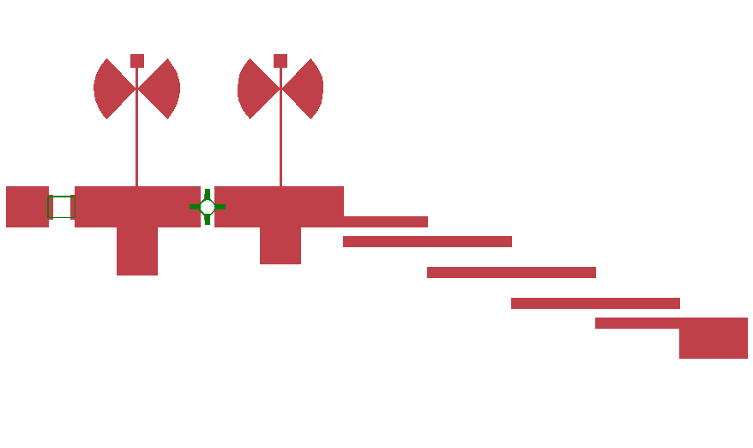.
Layout of designed amplifier having used a microwave circuit simulator.
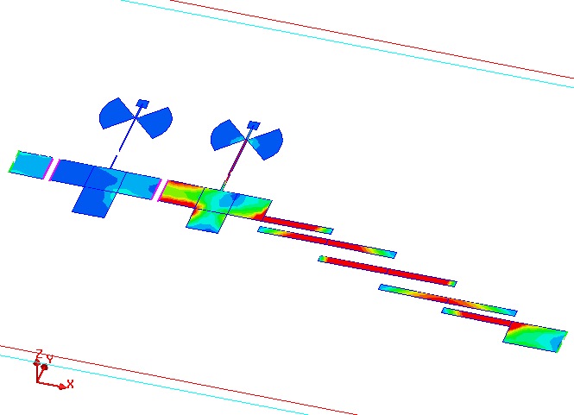
Analysis of designed amplifier by an electromagnetic simulator. Determination of current distribution and its animation – phenomena observation of amplifying as well as standing wave in filter resonators.

